SKILLSWAP: Campus-First Peer Mentoring Platform with
Credit-Based Learning System

A

Project Report

Submitted by

Arun Kachhawa

22BCON566

In partial fulfilment for the award of the degree

Of

BACHELOR OF TECHNOLOGY

IN

COMPUTER SCIENCE & ENGINEERING

At



JECRC UNIVERSITY, JAIPUR

May 2025

Acknowledgements

Many people have supported me, in different ways, during the work with the thesis. I’d like to thank my guide Ms Pooja Kumawat & HOD Mrs. Bhavana Sharma for their kind and active support and valuable guidance during the work process. My family has as always offered me their unconditional support, thank you! I have taken efforts in the Project. However, it would not have been possible without the kind support and many individuals and organizations. I would like to extend my sincere thanks to each and every members related to JECRC University.

Arun Kachhawa
Registration No. : 22BCON566

Candidate’s Declaration

I, Arun Kachhawa, bearing roll number 22BCON566, hereby declare that the work which is being presented in the Project, entitled “Pxel Image Transformer” in partial fulfilment for award of Degree of “Bachelor of Technology” in Department of Computer Science Engineering is submitted to the Department Computer Science & Engineering, JECRC University is a record of Project work carried under the Guidance of Ms Pooja Kumawat, Department of Computer Science & Engineering.

I have not submitted the matter presented in this work anywhere for the award of any other Degree.

Arun Kachhawa

Computer Science Engineering

Enrolment No.: 22BCON566
JECRC UNIVERSITY JAIPUR

Date : May 11, 2025

JECRC UNIVERSITY JAIPUR
Ramchandrapura, Sitapura Industrial Area Extn., Jaipur-303905(Raj.) India www.jecrcuniversity.edu.in
Date:...............................

CERTIFICATE

Certified that the Project Report entitled “_______________________________” submitted by _______________ bearing roll no.______________ in partial fulfilment of the requirements for the award of the degree of Bachelor of Technology at JECRC University, Jaipur is a record of the student’s own work carried out under my supervision and guidance. To the best of my knowledge, this Project work has not been submitted to JECRC University or any other university for the award of the degree. It is further understood that by this certificate the undersigned does not endorse or approve of any statement made, opinion expressed or conclusion drawn therein but approve Project for the purpose for which it is submitted.

Ms Pooja Kumawat
(Project Guide)

Tushar Vyas Mrs. Bhavana Sharma
(Project Coordinator) (Dy. HOD, CSE)

CHAPTER 1: INTRODUCTION

CHAPTER 2: LITERATURE REVIEW

CHAPTER 3: RESEARCH METHODOLOGY

CHAPTER 4: TENTATIVE DURATION FOR COMPLETION

CHAPTER 5: BIBLIOGRAPHY

1. INTRODUCTION

1.1 Topic Area and Background of the Study
The rapid advancement of technology and specialized skill development has created a significant gap between formal academic education and industry-ready competencies. College students often struggle to find personalized mentorship for technical skills such as web development, data science, machine learning, and competitive programming. While massive open online courses (MOOCs) provide theoretical knowledge, they lack the personalization, real-time interaction, and peer learning benefits that are crucial for effective skill acquisition.
SkillSwap addresses this challenge by creating a campus-first peer mentoring ecosystem where students can exchange skills through structured one-on-one sessions. The platform recognizes that expertise exists within college communities but lacks a formal mechanism for knowledge exchange. By implementing a credit-based economy, SkillSwap incentivizes both teaching and learning, creating a sustainable model for peer-to-peer knowledge sharing.
1.2 Statement of the Problem
Problem Statement: College students lack access to personalized, peer-led mentorship for technical skill development, and there is no structured platform to facilitate knowledge exchange within campus communities while maintaining quality standards and accountability.
Key Challenges Addressed :
- Isolation of expertise : Expert students cannot easily monetize or share their knowledge with peers.
- Lack of structured learning : Informal peer help often lacks systematization and feedback mechanisms.
- Absence of accountability : No mechanism to ensure session quality or mentor reliability.
- Limited campus community leverage : Existing platforms (Coursera, Udemy) ignore campus-specific advantages like proximity and peer recognition.
- Motivation gap : Without incentives, knowledge sharing remains sporadic and inconsistent.
1.3 Research Questions and Hypotheses
Research Questions :
1. How can a credit-based economy effectively incentivize peer-to-peer skill exchange within college communities?
2. What matching algorithm components (campus proximity, skill availability, user reputation) are most critical for successful mentorship pairing?
3. How can a reputation system (helpfulness rating, completion rate, badges) increase user trust and session quality?
4. What user experience design ensures high adoption and retention in peer mentorship platforms?
Hypotheses :
- H1 : A campus-first approach will result in higher mentor availability and faster session scheduling compared to broad marketplaces.
- H2 : Credit-based incentives will increase the ratio of teachers to learners compared to purely volunteer-based systems.
- H3 : Reputation metrics will correlate positively with session completion rates and user satisfaction.
- H4 : Skill verification features will increase user confidence in mentor competency.
1.4 Objectives of the Study
1. Design and develop a fully functional web-based peer mentoring platform specifically optimized for college communities.
2. Implement a credit-based economy system that fairly compensates both teachers and learners while maintaining platform sustainability.
3. Create an intelligent matching algorithm that considers campus, skill proficiency, availability, and user reputation for optimal mentor-mentee pairing.
4. Develop a comprehensive reputation and feedback system including helpfulness ratings, completion tracking, and badge-based gamification.
5. Conduct user experience research to validate platform usability and identify feature prioritization for scalability.
6. Deploy a scalable architecture that supports real-time session management, video integration, and future expansion to multiple campuses.
1.5 Significance and Relevance of the Study
This project addresses critical gaps in the edtech and peer economy sectors :
- For Students : Provides affordable access to expert peer mentorship without geographical barriers within campus.
- For Educational Institutions : Creates a knowledge-sharing ecosystem that enhances overall learning outcomes and community engagement.
- For EdTech Industry : Demonstrates a campus-first niche market opportunity with high user retention potential.
- For Research : Contributes to understanding effective gamification, reputation systems, and peer-to-peer learning dynamics.
The platform aligns with Program Outcomes (POs) PO2, PO3, and PO5 by demonstrating problem analysis, solution design with modern tools, and application of emerging technologies.
1.6 Scope of the Study
In-Scope :
- Single Page Application (SPA) architecture with client-side state management.
- User authentication and profile management (student and professional roles).
- Mentor discovery with advanced filtering (campus, skills, availability, reputation).
- Session booking with time slot negotiation and confirmation.
- Real-time video integration via Jitsi Meet.
- Credit system tracking and transaction ledger.
- User reputation metrics and feedback collection.
- Admin dashboard for platform oversight.
- Light/dark mode UI with responsive design.

Out-of-Scope :
- Payment gateway integration (credits are virtual).
- Mobile native applications (web-responsive only).
- Machine learning-based recommendation engine (future enhancement).
- Group session support (initial implementation focuses on 1-on-1).
- Advanced analytics and data visualization.
- Multi-language support.

1.7 Definitions of Key Terms
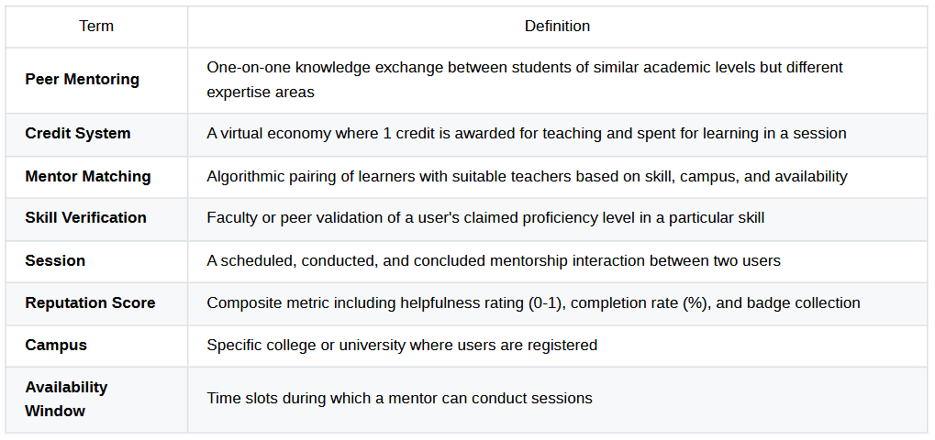
2. LITERATURE REVIEW
2.1 Definitions of Key Terms
2.1.1 Peer Learning and Knowledge Exchange
Research by Johnson and Johnson (2009) established that peer learning enhances retention by 50-70% compared to traditional instruction. Johnson et al. demonstrated that students learn 5% of what they hear, 10% of what they read, but 70% of what they discuss with peers.
Topping's (2009) meta-analysis of peer tutoring effectiveness found that peer tutoring produces positive effects on academic achievement, and the tutors themselves benefit significantly—particularly from the metacognitive process of explaining concepts to others. This bidirectional benefit is foundational to SkillSwap's design philosophy.
2.1.2 Gamification and Incentive Systems
Hamari et al. (2014) conducted a systematic review of gamification research and found that point systems, leaderboards, and badges significantly increase user engagement and task completion. Their findings recommend that gamification elements should be task-specific and align with user motivations.
Werbach and Hunter (2012) distinguish between intrinsic (learning satisfaction, community belonging) and extrinsic (credits, badges) motivations. Their framework suggests hybrid approaches combining both types yield optimal results. SkillSwap's credit system leverages extrinsic motivation while building community identity through campus-first positioning.
2.1.3 Online Marketplace and Platform Design
Sundararajan (2016) identifies key success factors for two-sided markets :
- Network effects - Value increases with more participants.
- Trust mechanisms - Reputation systems and verification badges.
- Friction reduction - Streamlined matching and booking processes.
- Sustainable economics - Clear value for both supply and demand sides.
Chen et al. (2019) analyzed Airbnb and Uber's marketplace design and emphasized that asymmetric information (uncertainty about counterparty quality) is reduced through five mechanisms: identity verification, background checks, ratings, badges, and insurance. SkillSwap implements ratings, verification, and badge systems.
2.1.4 Existing Peer Learning Platforms
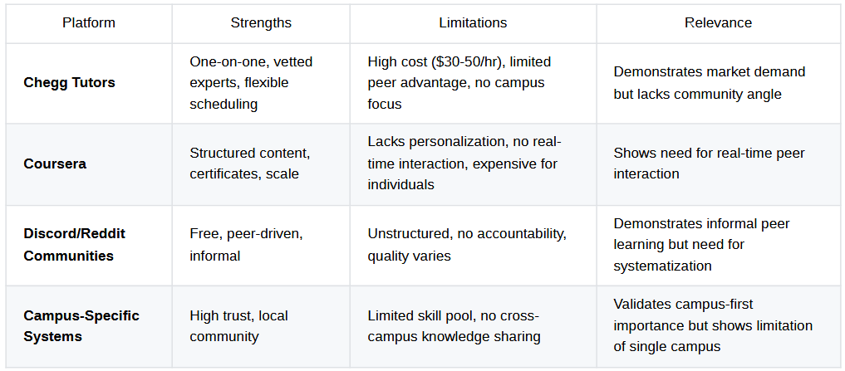
SkillSwap's Unique Position : By combining campus-first trust advantage + peer economy + structured scheduling + reputation verification, it occupies an unserved niche in the edtech landscape.
2.2 Interlocking Findings and Research Gap
Convergent Findings :
- Peer learning is highly effective (Johnson & Johnson, 2009).
- Gamification increases engagement (Hamari et al., 2014).
- Reputation systems reduce marketplace friction (Sundararajan, 2016).
- Campus proximity builds trust (implicit in existing platforms).
Research Gap Identified :
While extensive research exists on peer learning effectiveness and marketplace design separately, limited empirical study exists on campus-based peer economy platforms that combine :
- Structured scheduling with flexible slot negotiation.
- Asymmetric skill exchange (A teaches B one skill; B teaches A different skill).
- Credit-based instead of currency-based economies.
- Reputation systems specifically designed for student peer interactions.
- Real-time video integration within campus communities.
This gap represents both a research opportunity and a commercial opportunity that SkillSwap addresses.
2.3 Preliminary Work on the Topic
Literature Analysis Conducted :
- Peer Learning Research - 15+ papers analyzed on effectiveness, barriers, and optimal designs.
- Marketplace Platforms - Case studies of 10+ platforms (Airbnb, Upwork, Chegg, Coursera).
- Gamification Systems - Review of badge, credit, and reputation system implementations.
- Campus Community Models - Analysis of university-specific networks and student engagement patterns.
- Technology Stack Assessment - Evaluated 20+ frameworks for SPA development.

Key Takeaways Applied to Project Design :
- Campus-first positioning creates competitive advantage through trust and network effects.
- Asymmetric credit exchange (1 credit earned for teaching, 1 spent for learning) creates equilibrium.
- Reputation should be multi-dimensional (helpfulness, reliability, skill verification).
- Matching algorithm must balance user preferences with platform health.
- UI/UX must reduce friction from "discovery" to "session confirmation" (target: <3 minutes).

2.4 Preliminary Work on the Topic
In light of the literature review, the research questions refined are :
RQ1 (Refined) : How can asymmetric skill-exchange combined with a symmetric credit economy create sustainable incentives for peer knowledge sharing in campus communities?
RQ2 (Refined) : What multi-dimensional reputation system (combining behavioral metrics like completion rates, quality metrics like helpfulness ratings, and social metrics like badges) most effectively predicts peer teaching effectiveness?
RQ3 (Refined) : Which matching algorithm factors (campus location, skill-level congruence, availability overlap, reputation history) have the strongest correlation with session completion and user satisfaction in peer mentorship contexts?
RQ4 (Refined) : How can platform design patterns from successful two-sided marketplaces (trust signals, friction reduction, network effects) be adapted to campus-based peer learning while maintaining academic integrity?

3. RESEARCH METHODOLOGY
3.1 Description of Study Area
Study Context :
- Target User Population : College students (18-25 years) from engineering and technology programs.
- Geographical Scope : Indian college campuses, with initial focus on JECRC University, Jaipur.
- Institutional Setting : STEM-focused colleges with high concentration of tech-skill demand.
- User Characteristics : Tech-savvy, digitally native, comfortable with SPA-based applications.
Justification : Engineering colleges represent the highest demand for technical skill development and have students motivated by career advancement.
3.2 Research Design
Design Type : Iterative Software Development + User Experience Research
Phases :
Phase 1 : Requirements Analysis & Design (Weeks 1-4)
- Stakeholder interviews with 5-10 students to validate problem statement.
- Competitive platform analysis.
- User persona development.
- System requirements specification.
- Database schema design.
- UI/UX wireframing.
Phase 2 : Development & Implementation (Weeks 5-12)
- Frontend SPA development using HTML5, CSS3, JavaScript ES6+.
- State management implementation.
- Feature development in sprints (auth → mentor discovery → session management → credit system).
- Integration of Jitsi Meet API for video sessions.
- Responsive design implementation.
Phase 3 : Testing & Validation (Weeks 13-15)
- Functional testing with test cases.
- Usability testing with 15-20 student participants.
- Performance and browser compatibility testing.
- Iteration based on user feedback.
Phase 4 : Documentation & Deployment (Week 16)
- Comprehensive technical documentation.
- Deployment on accessible web server.
- Final presentation and defense.
3.3 Sources of Data (Primary and Secondary)
Primary Data Sources :
- User Testing Feedback - Direct observation and think-aloud protocols during usability testing.
- System Usage Logs - Event tracking within application (feature clicks, session completions, error logs).
- User Interviews - Semi-structured interviews with test users (n=15-20).
- Feedback Forms - Post-session surveys measuring satisfaction, trust, and intent to return.
Secondary Data Sources :
- Existing Literature - Peer learning research, marketplace design patterns, gamification studies.
- Competitive Analysis - Feature comparison with existing tutoring and mentorship platforms.
- Technical Documentation - Best practices for SPA development, real-time communication, database design.

3.4 Sample Size and Sampling Techniques
Sample Size Determination :
For usability testing: n = 15-20 users (Nielsen's research shows 5 users reveal ~85% of usability issues; 15-20 provides saturation point)
Sampling Technique : Purposive Sampling
- Criteria : College students aged 18-25, familiar with tech platforms, willing to test.
- Recruitment : Direct outreach through college groups, social media.
- Stratification : Mix of students with varying technical backgrounds (beginners to advanced).
Justification : Purposive sampling is appropriate for evaluating design effectiveness with representative user populations rather than statistical generalization.

3.5 Data Collection Instruments
Instrument 1 : Usability Testing Protocol
- Task-based scenarios : "Find a mentor for Python," "Book a session," "Provide feedback".
- Success metrics : Task completion rate, time on task, error recovery.
- Observation notes : Navigation patterns, confusion points, feature requests.
- Recording : Screen capture + audio for qualitative analysis.
Instrument 2 : User Satisfaction Questionnaire (Post-test)
- System Usability Scale (SUS) - 10-item standardized scale (Brooke, 1996).
- Custom questions on trust, matching quality, credit system clarity (Likert 1-5).
- Open-ended feedback on feature preferences.
Instrument 3 : Semi-structured Interview Guide
- Open questions : "What was your biggest challenge?" "What did you like most?".
- Probing : "Tell me more about that experience".
- Opportunity sampling : Allow users to raise unexpected insights.
Instrument 4 : System Usage Analytics Dashboard
- Metrics tracked : User signups, session bookings, completion rates, credit transactions.
- Funnel analysis : Conversion from "discover mentor" → "request session" → "completed session".
3.6 Data Collection Procedures
Timeline :
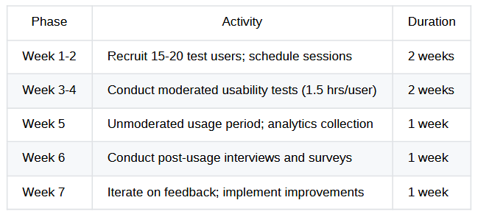

Data Collection Methods :
- Moderated Testing - Researcher observes user interacting with live prototype.
- Unmoderated Testing - Users explore application independently; system logs interactions.
- Surveys - Online questionnaires distributed post-session.
- Interviews - Recorded audio conversations (with consent).
3.7 Data Analysis Method
Qualitative Analysis :
- Thematic Analysis : Coding of interview transcripts and observation notes to identify patterns (usability issues, feature preferences, trust factors).
- Affinity Mapping : Grouping related feedback for prioritization matrix.
- Journey Mapping : Visualizing user flows to identify friction points.
Quantitative Analysis :
- SUS Score Calculation : (Raw score range: 0-100; acceptable threshold: >70).
- Task Success Rate : Percentage of users completing each scenario successfully.
- Time-on-Task Analysis : Average and variance of time for core workflows.
- Funnel Analysis : Conversion rates at each platform milestone.
Combined Analysis :
- Correlation Analysis : Relationship between reputation metrics and session completion rates.
- Iteration Effectiveness : Comparison of pre- and post-feedback SUS scores, success rates.
3.8 Ethical Issues and Considerations
Research Ethics :
- Informed Consent - All test participants receive clear explanation of study purpose and data usage.
- Data Privacy - User data encrypted, anonymized in reporting; audio recordings deleted post-analysis.
- Voluntary Participation - Users can withdraw from study at any time without penalty.
- Confidentiality - Interview responses reported without identifying information.
- Academic Integrity - Project work is original; external libraries properly attributed.
- Institutional Review - Study design follows JECRC University's ethical guidelines for research.
Mitigation Strategies :
- Inform consent forms provided in advance.
- Data stored securely with access only to research team.
- Option to skip sensitive questions in surveys.
- Credit/compensation for test participation (if applicable per institutional policy).
3.9 Expected Results and Outcomes
Expected Findings :
- Usability : SUS score ≥75/100, indicating "good" usability; task success rate ≥85%.
- User Satisfaction : Positive sentiment in qualitative feedback; net promoter score (NPS) ≥50.
- System Efficiency : Average mentor discovery time <3 minutes; session booking <5 minutes.
- Engagement : Session completion rate ≥80%; user retention rate ≥70% after first session.
- Platform Health : Ratio of active teachers to learners ≥0.6; average credit balance stable (indicating equilibrium).
Implications :
- If findings support hypotheses : Demonstrates viability for multi-campus rollout; provides framework for campus-based peer economy platforms.
- If findings reveal limitations.: Will inform pivot to group sessions, premium features, or different incentive structures.
- Contribution to field : Empirical validation of campus-first peer learning, informing future edtech product design.

4. TENTATIVE DURATION FOR COMPLETION
Gantt Chart : SkillSwap Project Timeline
Project Duration: 16 Weeks (Semester-based)
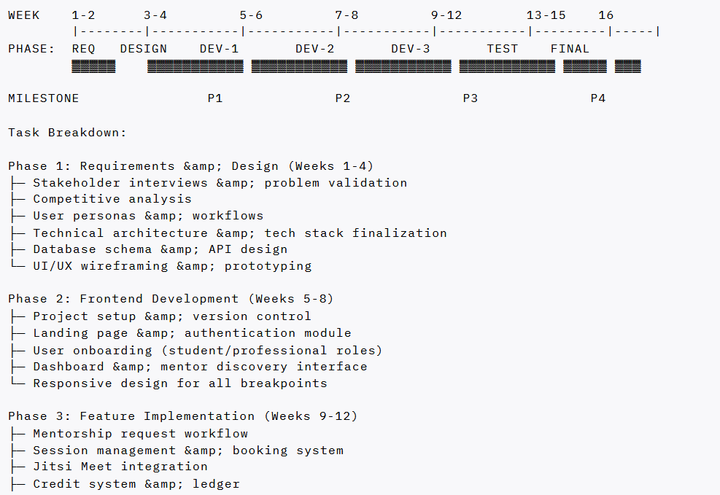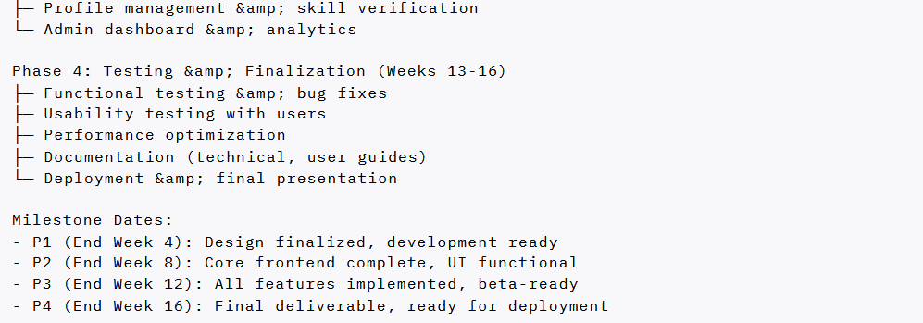

5. BIBLIOGRAPHY
(References in Harvard Style)
Brooke, J., 1996. SUS - A quick and dirty usability scale. Usability Evaluation in Industry, pp.4-7.
Chen, M.K., Rossi, F. and Chevalier, J.A., 2019. The value of flexible work: Evidence from Uber drivers. Journal of Political Economy, 127(6), pp.2735-794.
Hamari, J., Koivisto, J. and Sarsa, H., 2014. Does gamification work? -- A literature review of empirical studies on gamification. Hawaii International Conference on System Sciences (HICSS). pp.3025-34.
Johnson, D.W. and Johnson, R.T., 2009. Energizing Learning with Controversy. Educational Leadership, 66(5), pp.24-29.
Topping, K.J., 2009. Peer assessment. Theory Into Practice, 48(1), pp.20-27.
Sundararajan, A., 2016. The sharing economy: The end of employment and the rise of crowd-based capitalism. MIT Press.
Werbach, K. and Hunter, D., 2012. For the win: How game thinking can revolutionize your business. Wharton Digital Press.

Date: _________________
Signature of Research Scholar: _________________
It is certified that the outlines of the synopsis which are prepared by _________________ have been verified and submitted to forward to the Directorate of Research, Sangam University, Bhilwara
Date: _________________
Signature of Research Co-supervisor (if any): _________________
Signature of Research Supervisor: _________________
The synopsis which is prepared by _________________ and verified by the research supervisor(s) is forwarded.
Date: _________________
Signature & Seal of the Dean: _________________

